**NAUKRI.COM**

**WEB APPLICATION**

**Naukri.com is an Indian job portal which connects job seekers and employers. It is a platform where all job seekers can apply for jobs without any cost. After applying, Naukri sends all applications to the employers.**

**1.After opening the Naukri.com website the home page of it gets opened.**

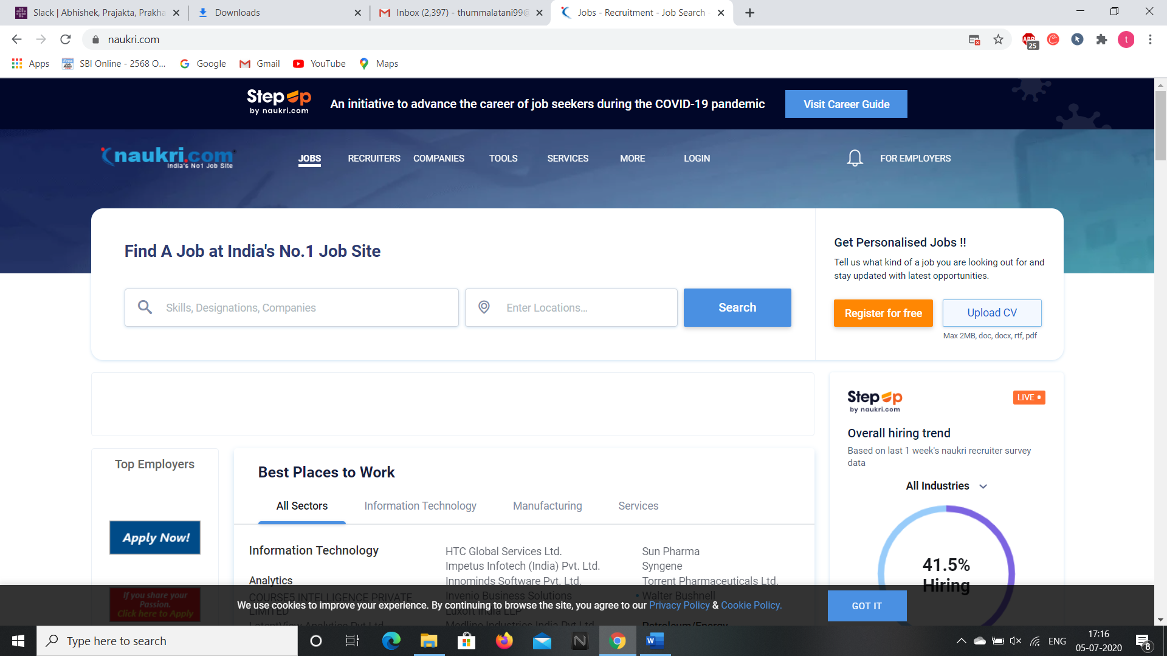

**2.We can search for the desired skill job by typing it in the search box and the location.**

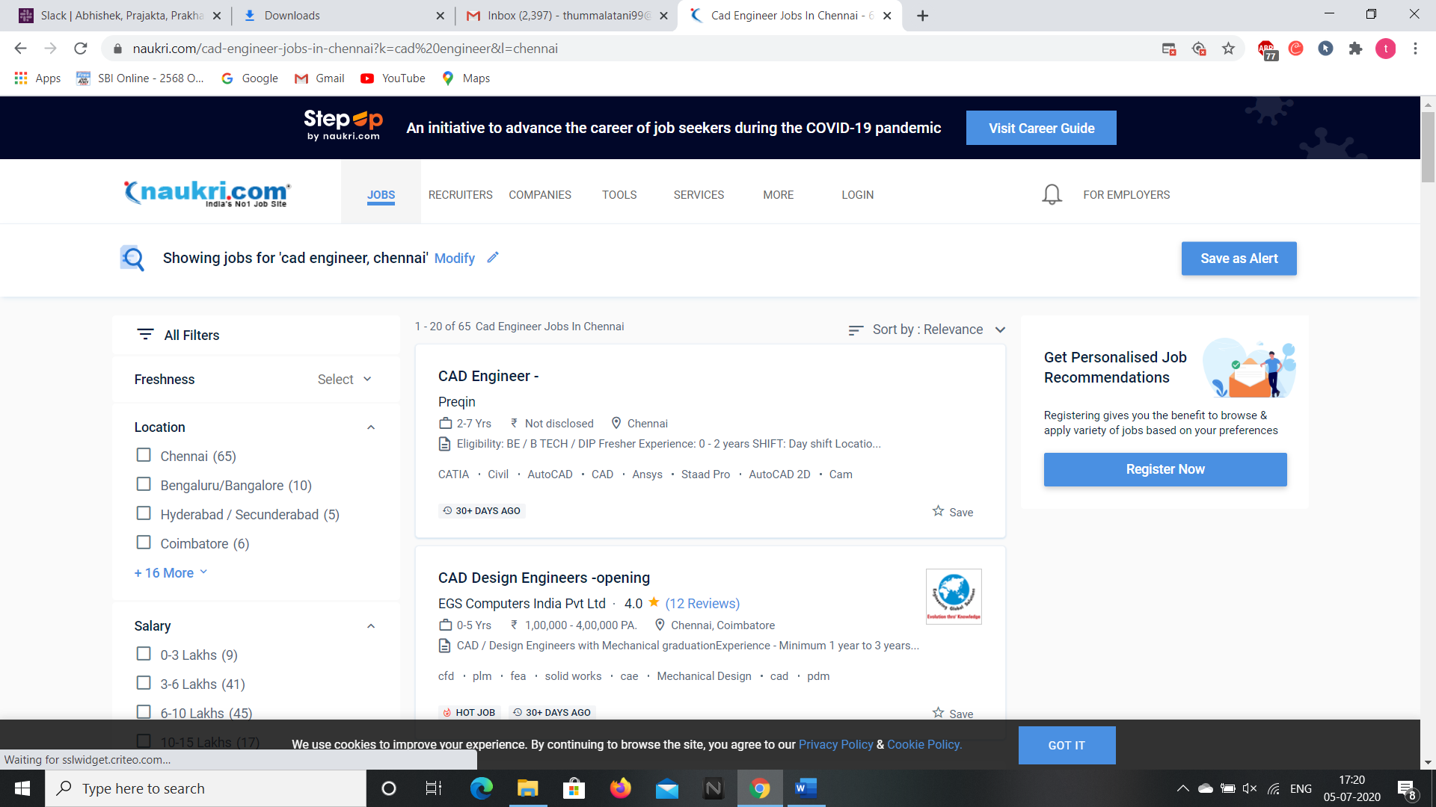

**3.Clicking the “Recruiters” option the recruiters home page opens up and we can browse the recruiters according to skills, companies, designations, location and category.**

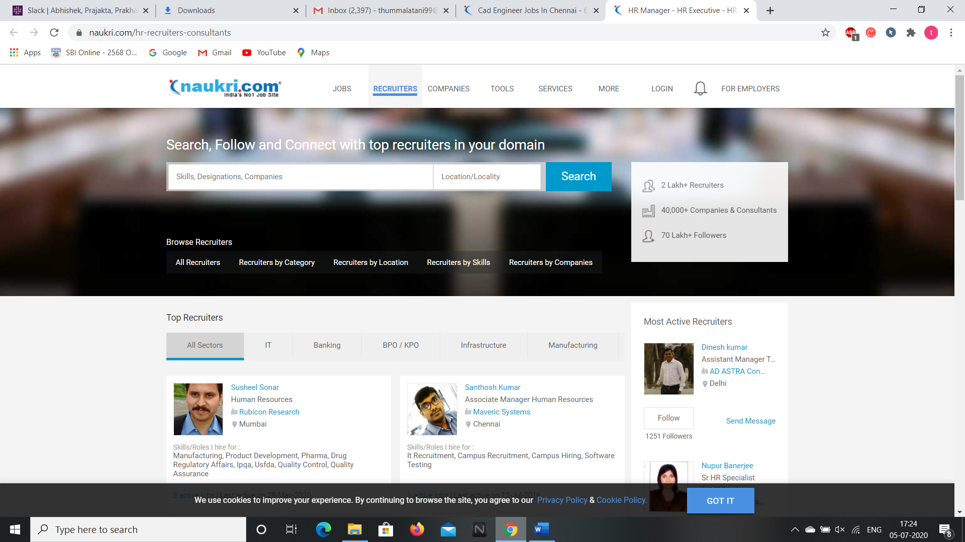

**4.Clicking the “Companies” option the search page by companies opens up and we can browse the jobs according to skills, category, loaction, designation, govt.jobs, IIT/IIM Jobs, International jobs and Walk-in jobs.**

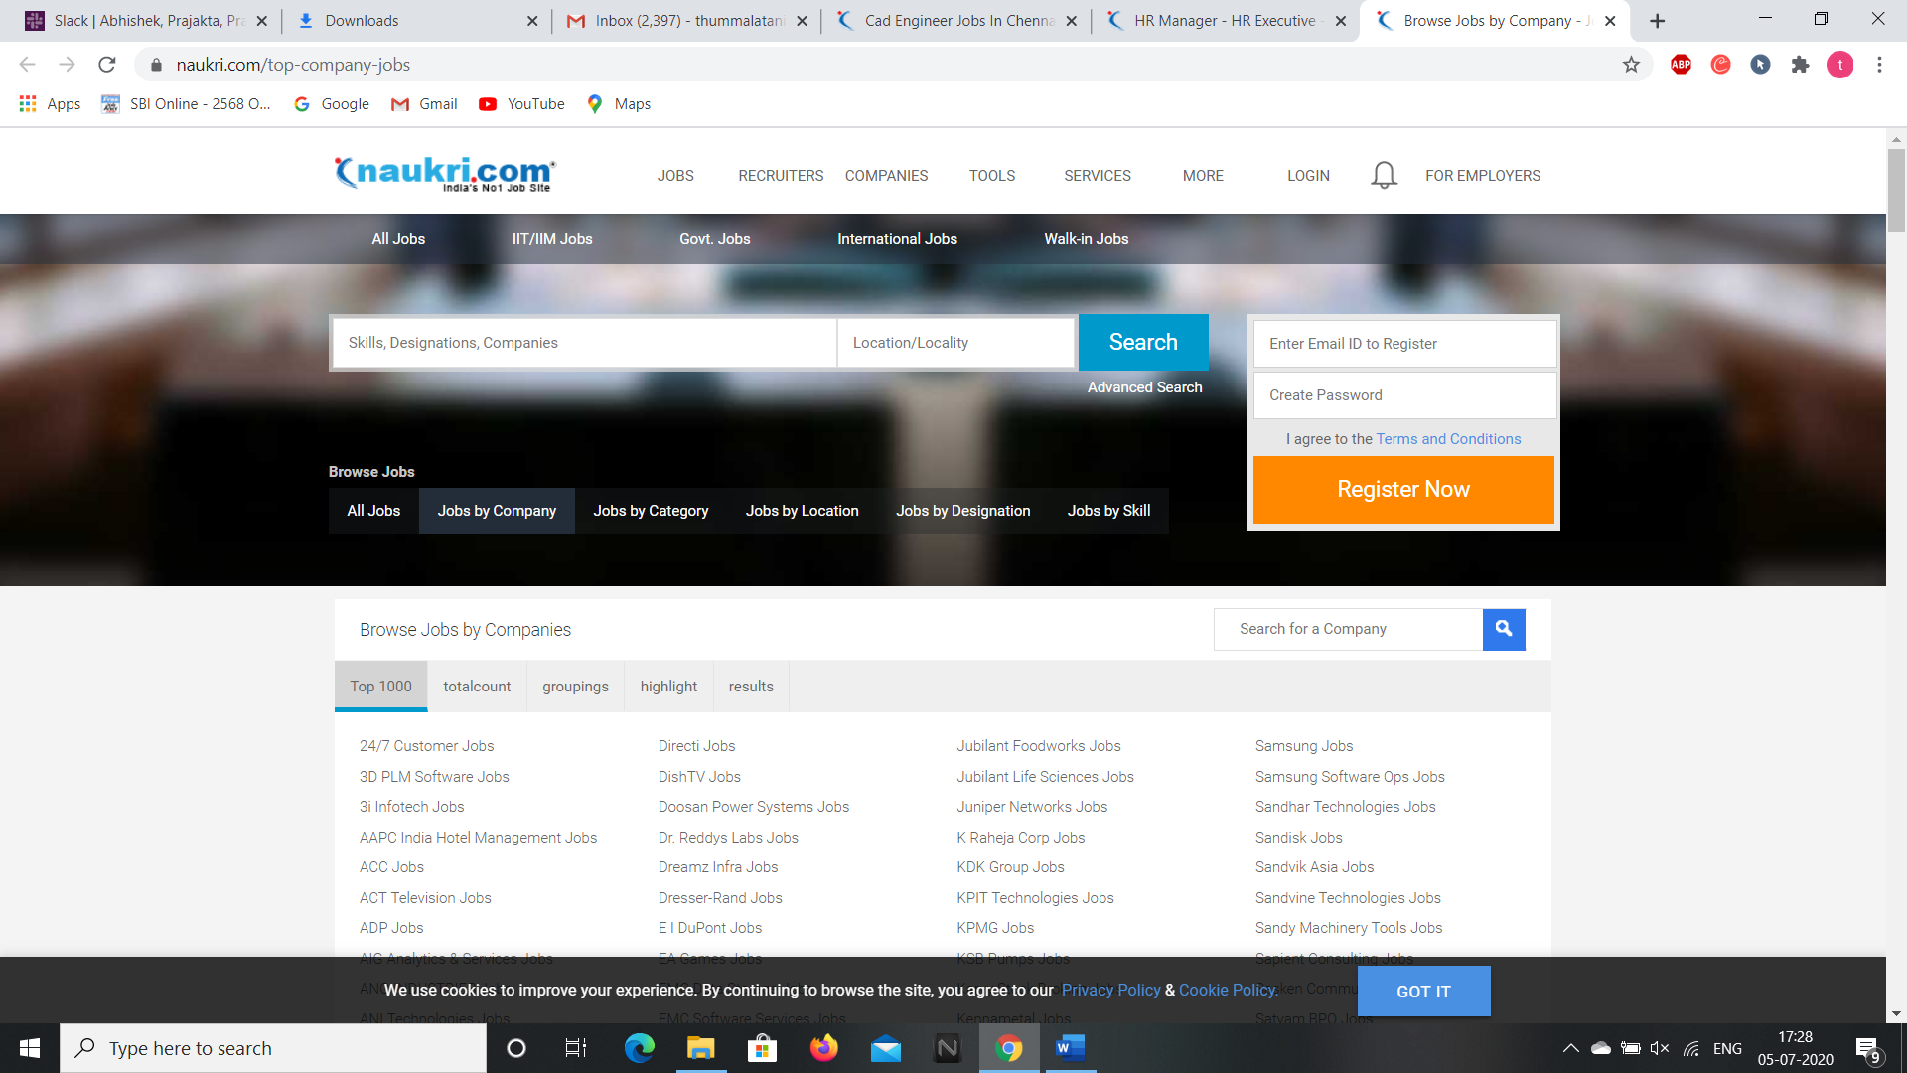

**5.We can open the trends sections by clicking on “Tools” option. The trends are Salary trends, Career Navigatorand other we pages consisting of People flow, Talent Migration, Salary Predictor page etc., can be found in the insights through the page of Tools.**

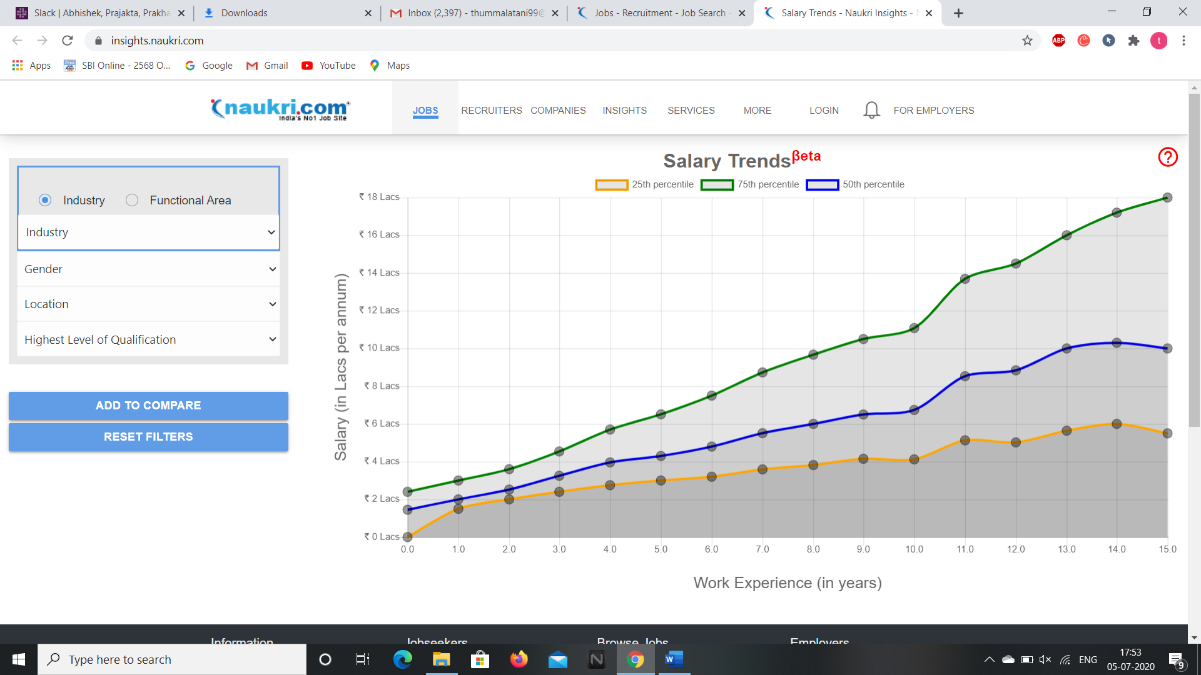

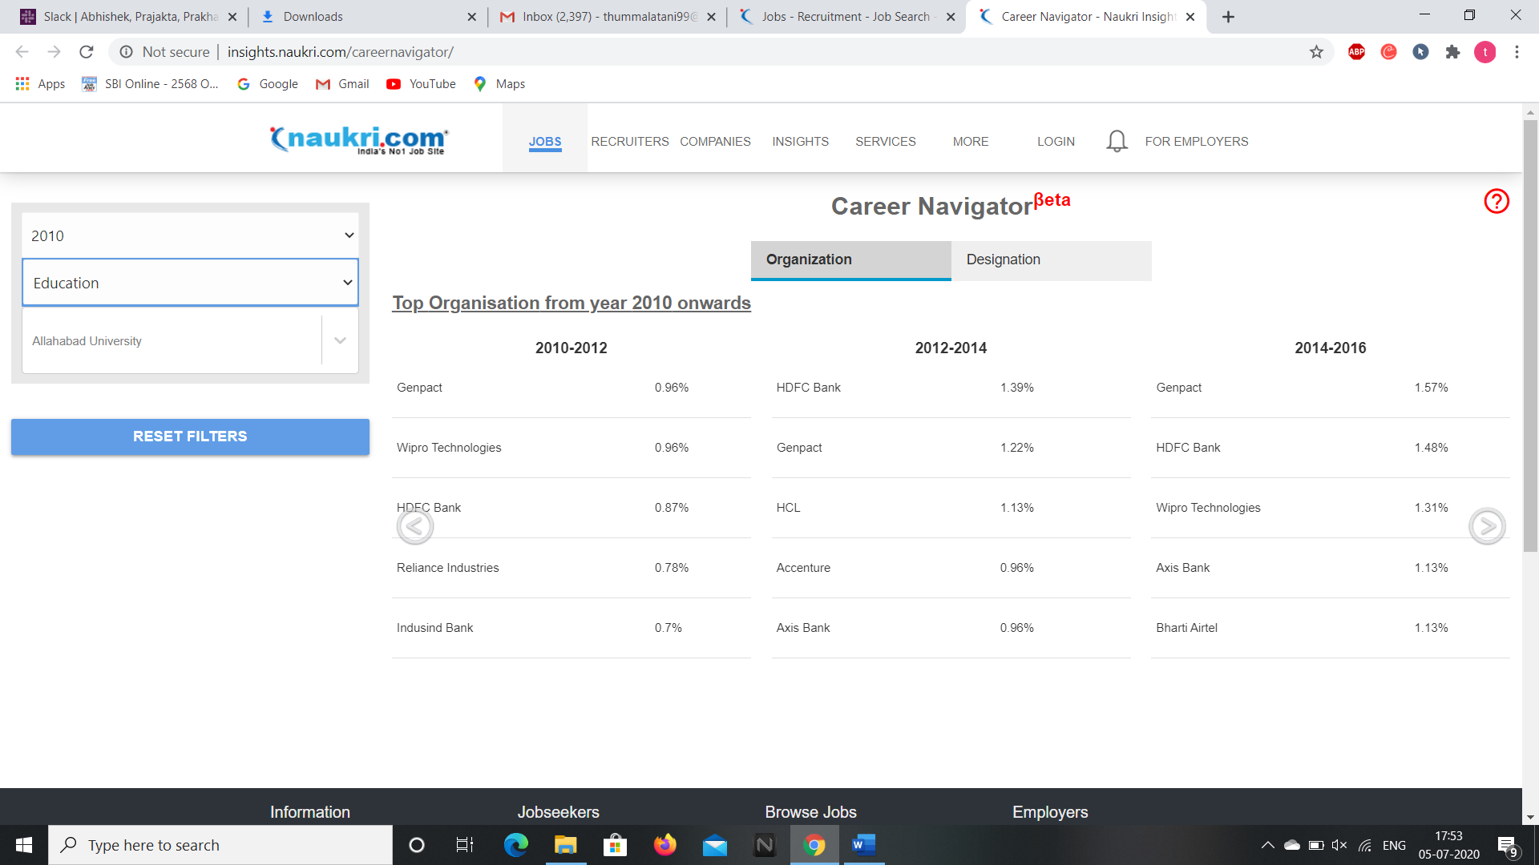

**6.Clicking on the “Services” option the web page providing services like Resume writing, Recruiter Reach, Priority Applicant, Interview Prep, Value Packs, Resume critique, Finding jobs and help gets opened.**

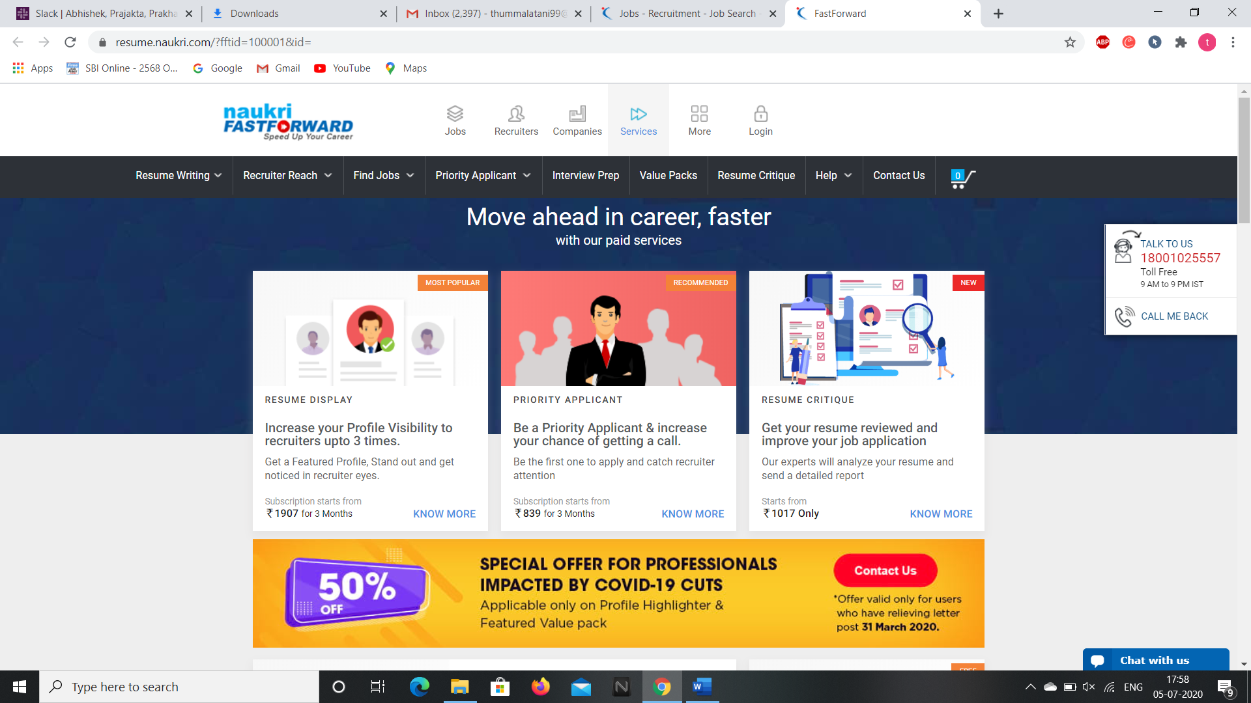

**This website is called as Naukri Fast Forward.**

**7.By clicking on more the naukri.shiksha web page gets opened and the details regarding studies in streams like MBA, Engineering, Medical, Design, Counseling etc., can be opened and help to find best colleges for us.**

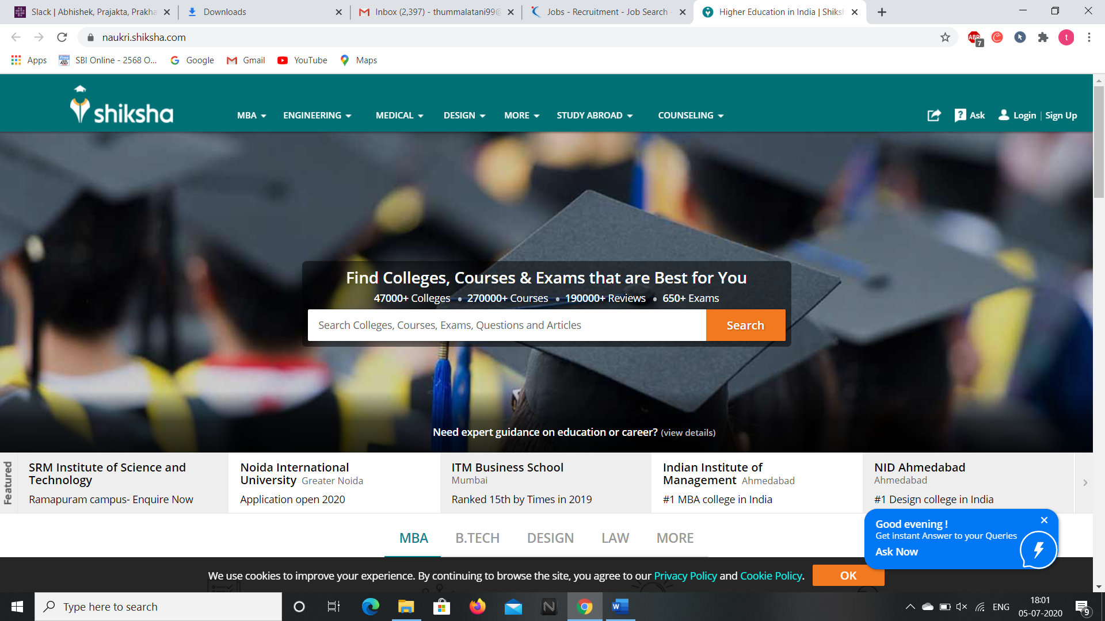

**8.The above things can only be accessed when the person signs up to the Naukri website. So to Sign up go back to the home page and click on “Register for free” option present at the right side of the web page.**

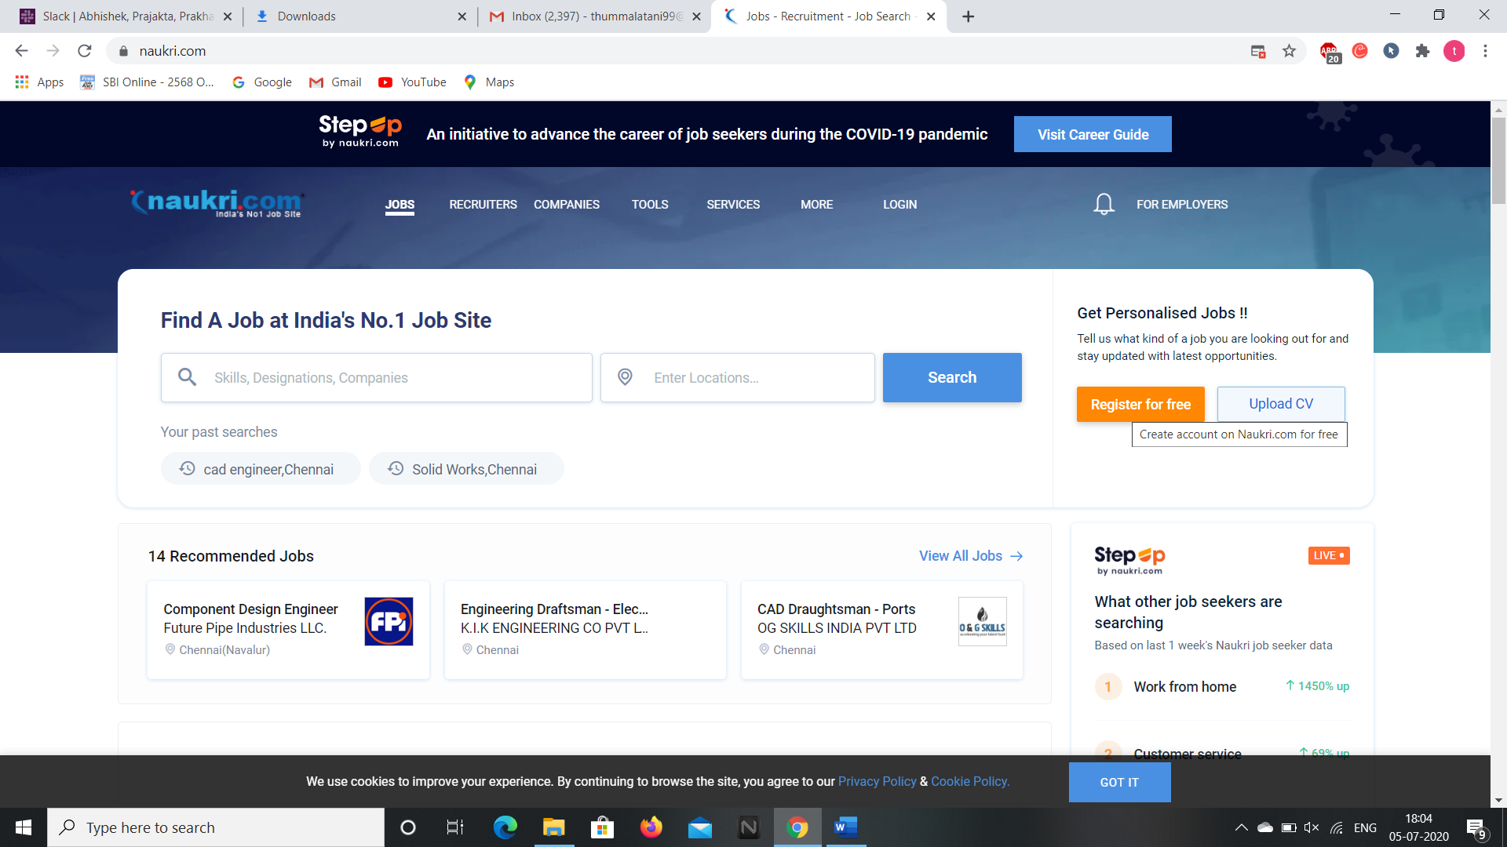

**9.It asks about work experience at the beginning and select the appropriate option.**

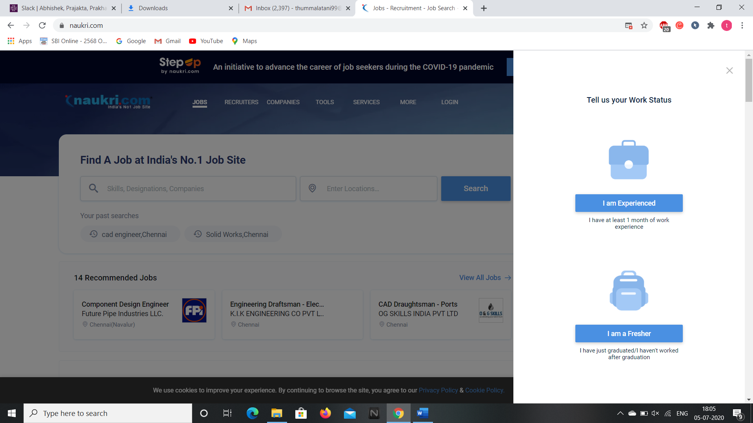

**10.The required details of the member should be filled in the boxes and upload your resume to and click on “Register now” to go to the next step.**

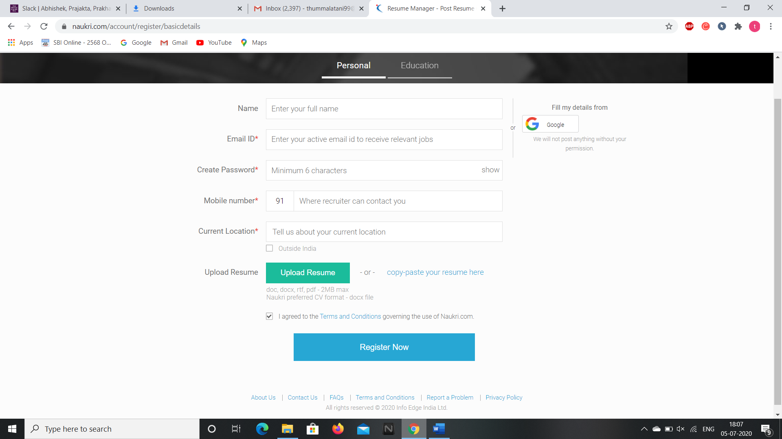

**11.The further details regarding education will be asked and fill the details to click on “Continue”.**

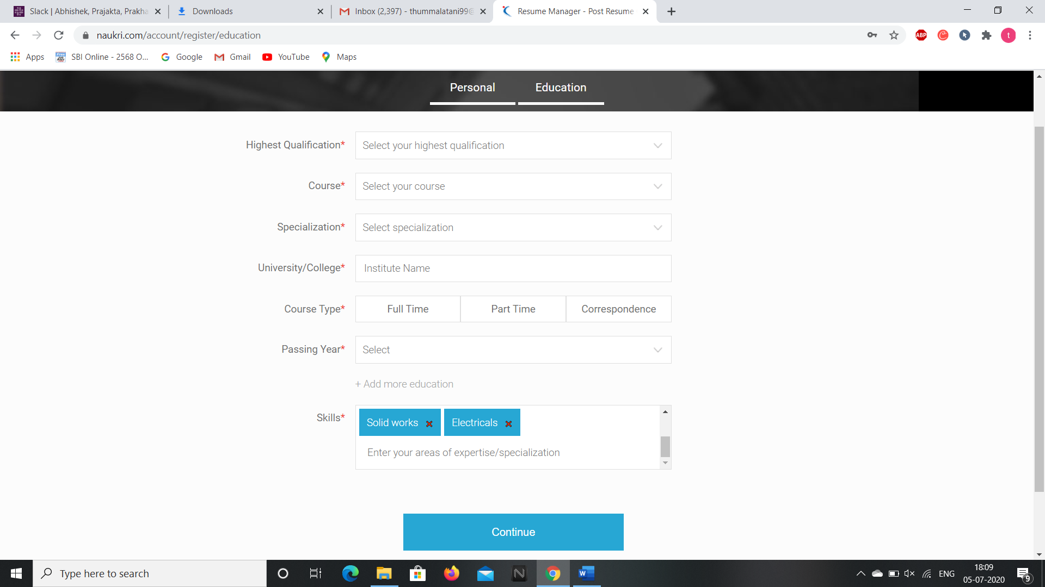

**12.Further details of the job seeker is asked to register and submit.**

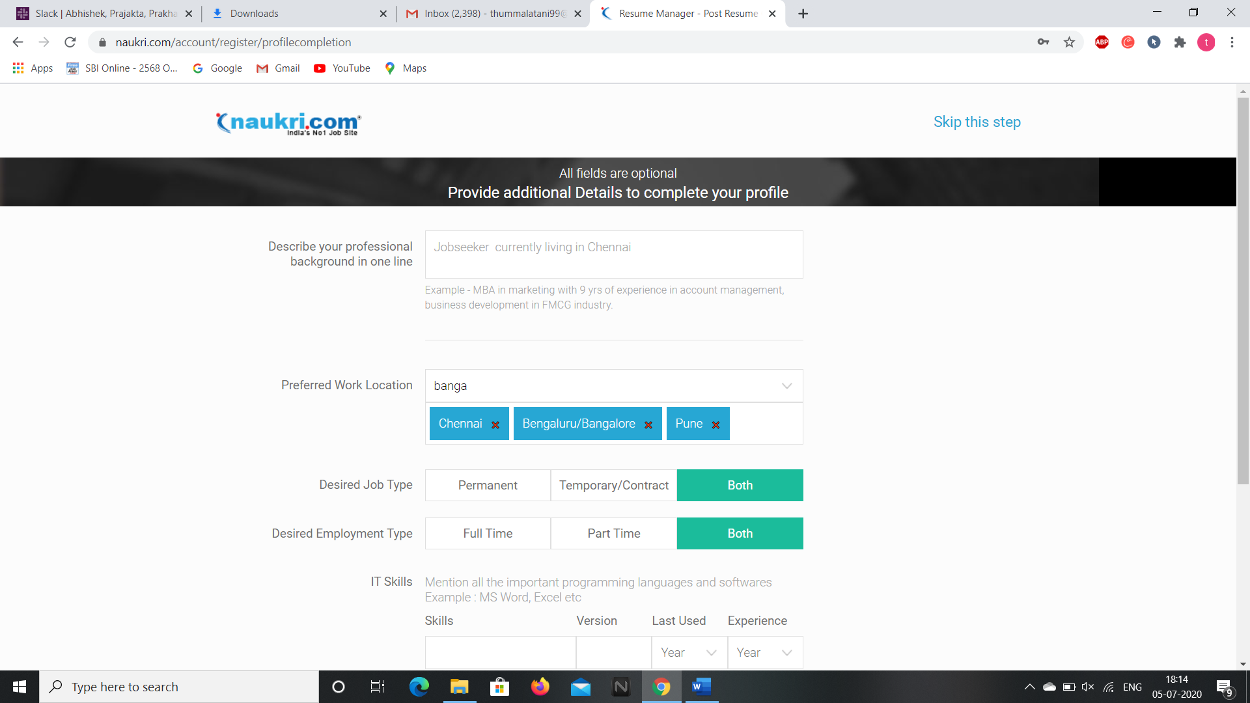

**13.Now your profile is created and we can apply jobs to recruiters by browsing depending on our skill.**

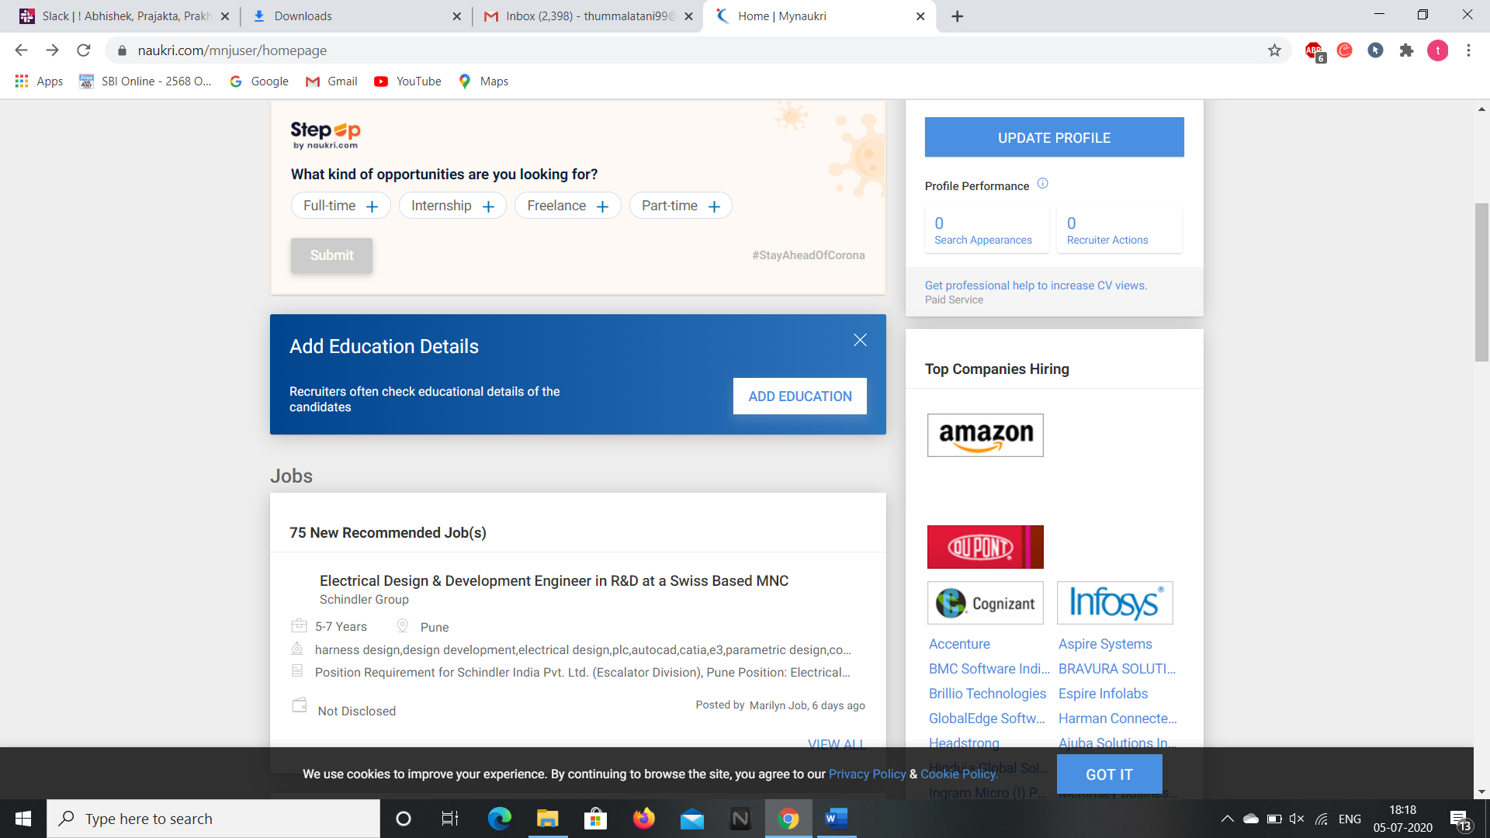

**So this is the way we can access the contents of this web application and we can access the webpage through selenium addon as well. Now, let’s see the android application of it.**

**ANDROID APPLICATION**

**We can download the android application through “Google Play Store” and installing it in the Virtual Phone through Android Studio.**

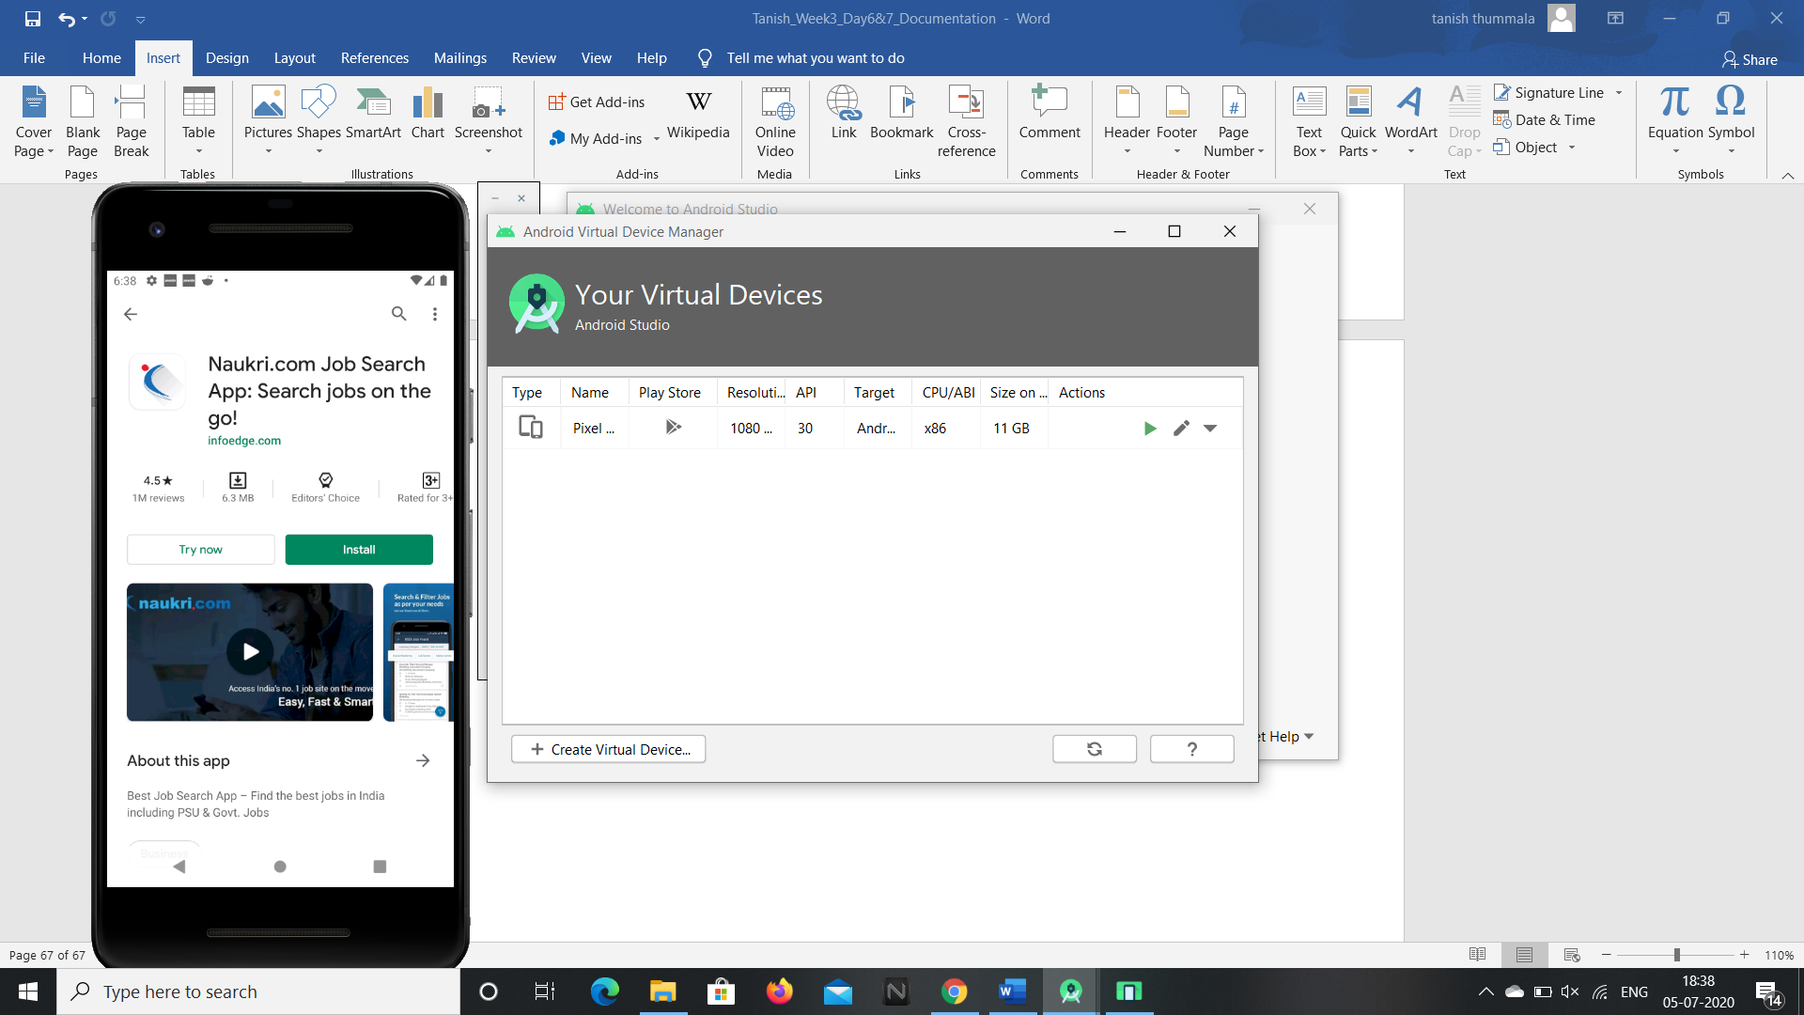

**1.After installing, open the app and we can search jobs through the search box.**

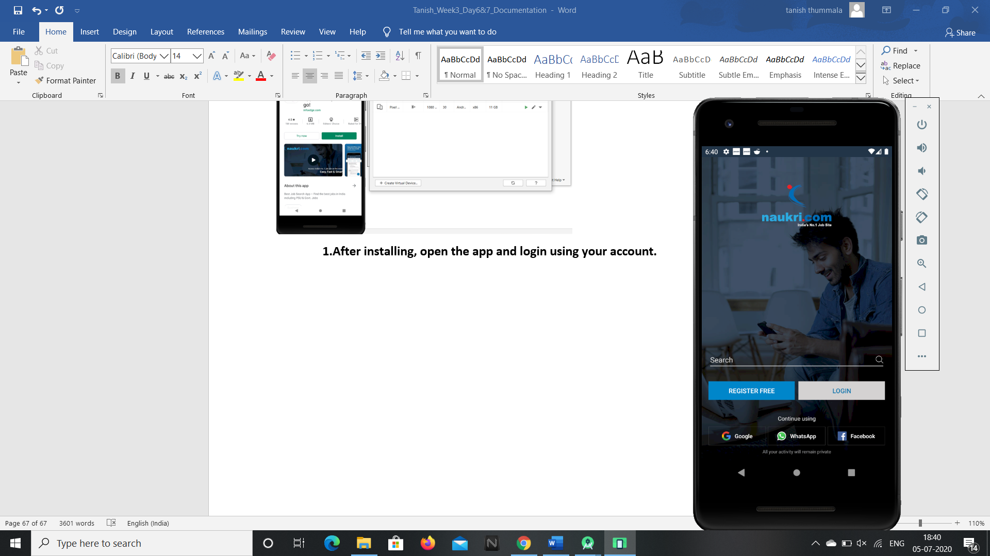

**2.Login to the website to access the profile page by giving our account details.**

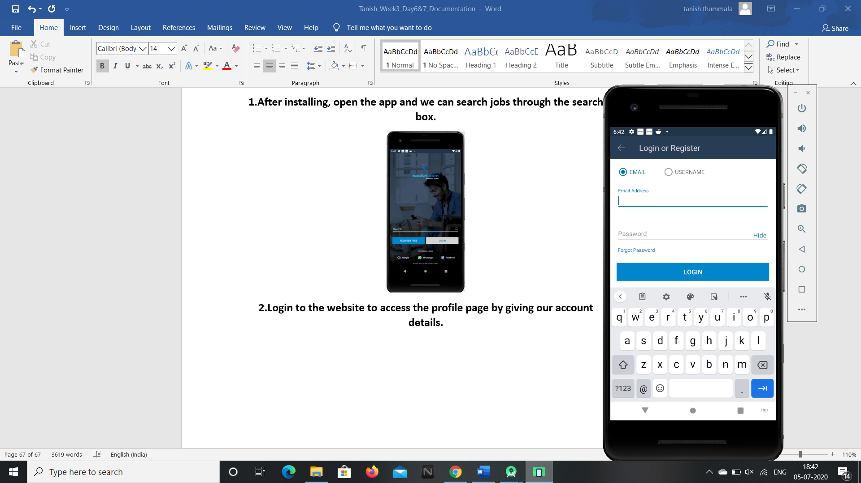

**3.In the home page we can see our profile details and to search for recruiters and profile details click on the icon present at the top left of the screen.**

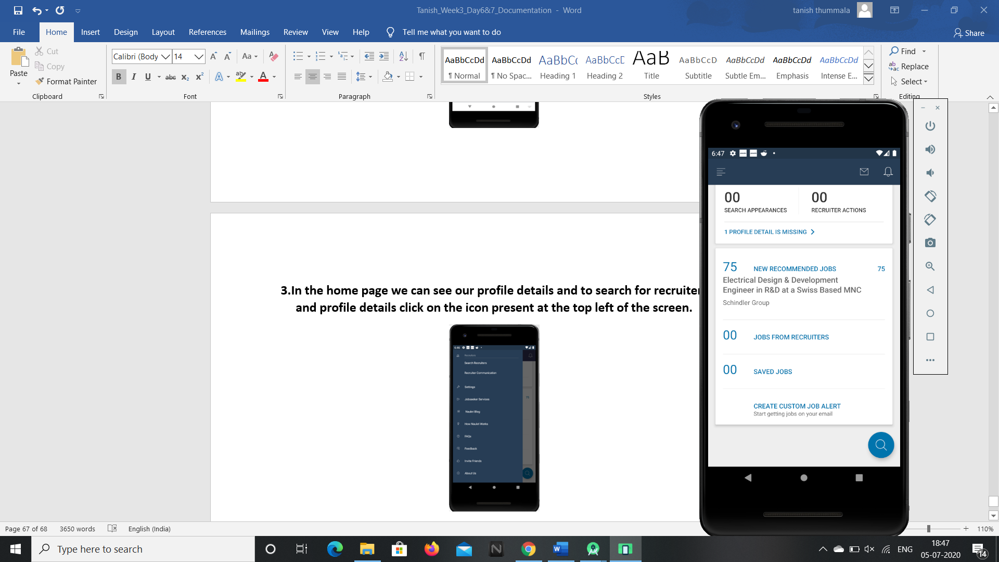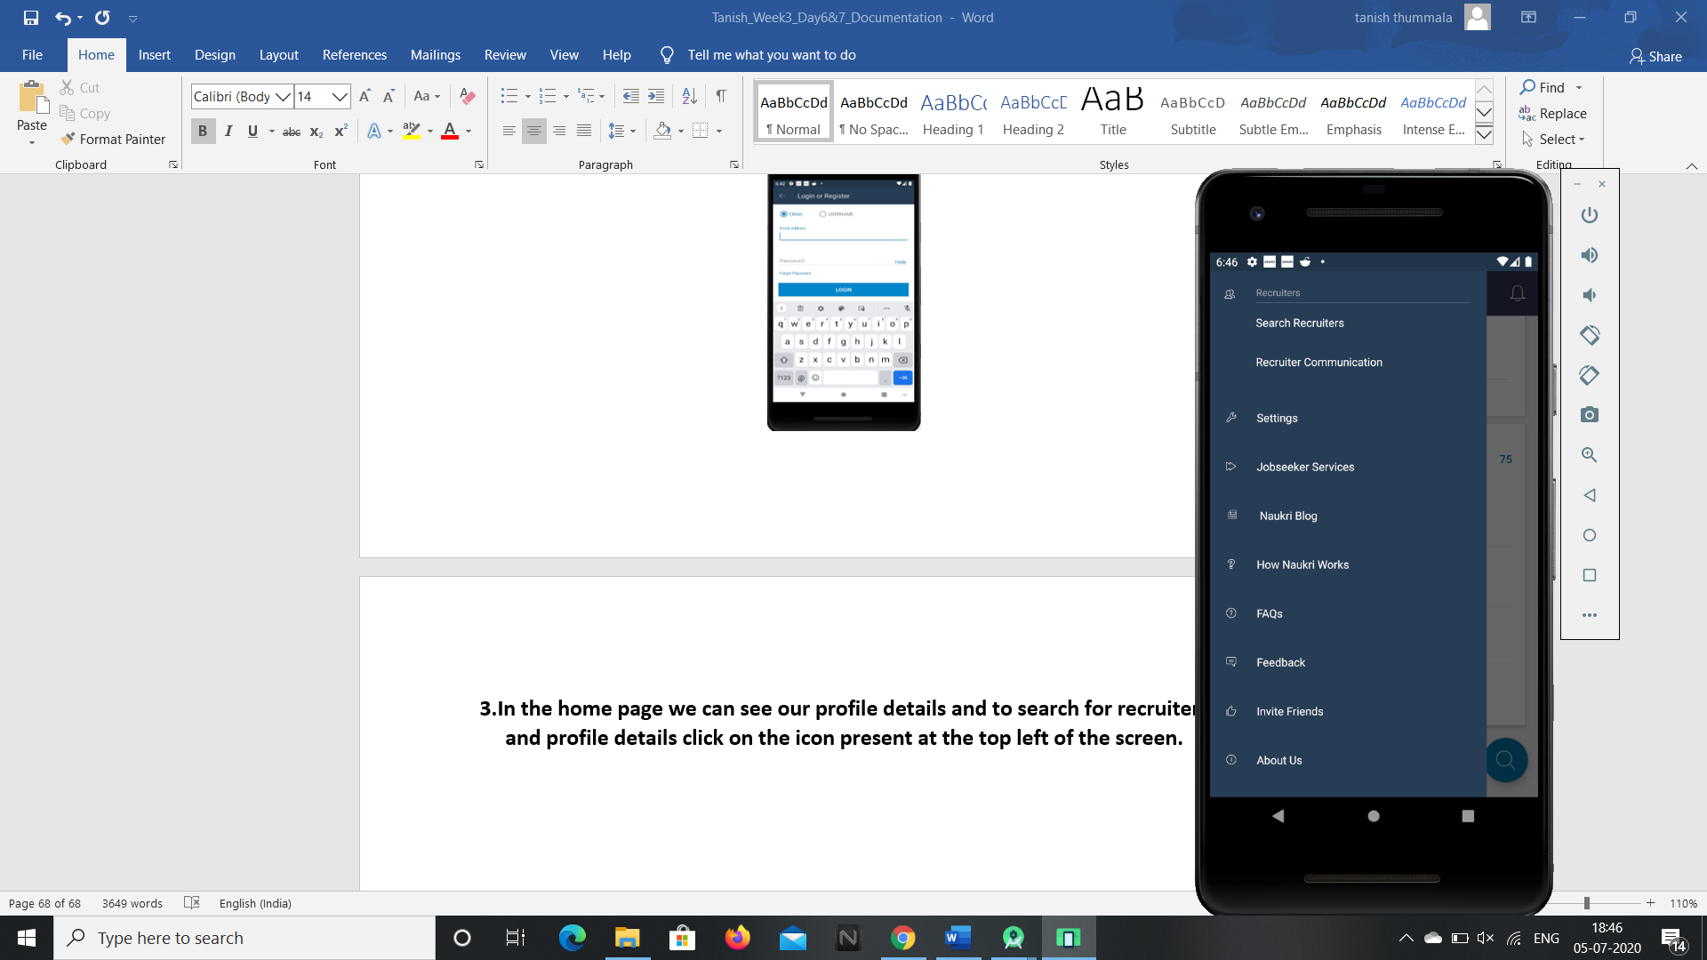

**4.Clicking on the search icon present on the bottom right of the screen we can search for jobs by giving the desired skills and location.**

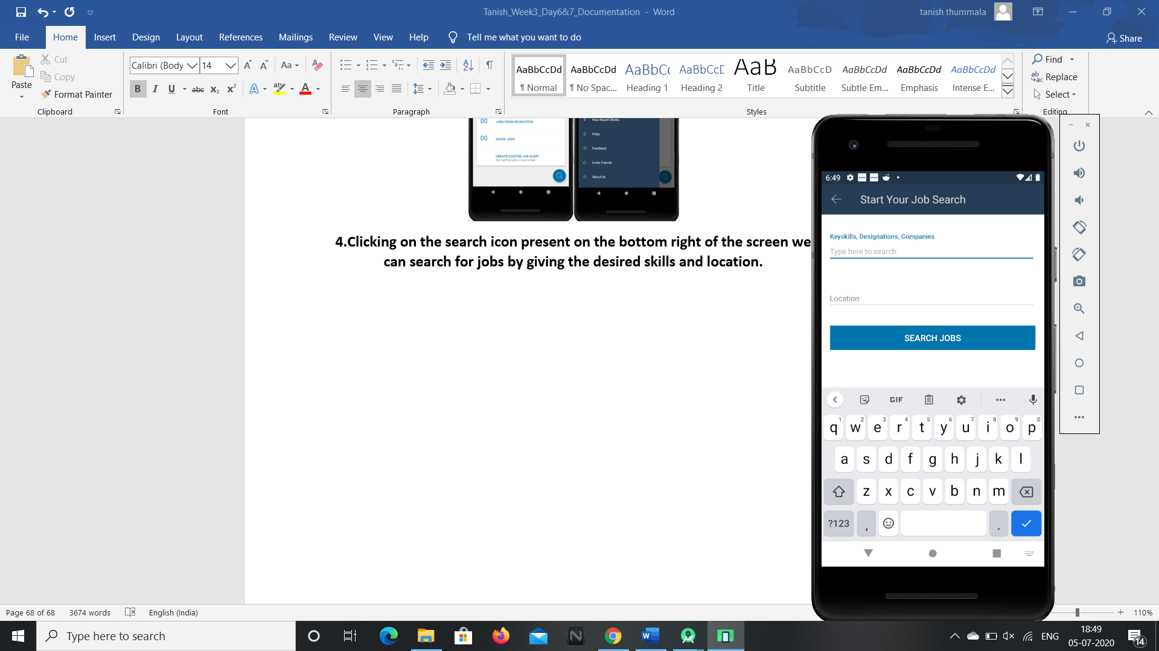

**5.Clicking on the message icon on the top right of the screen present left side of the bell icon the webpage containing messages sent by the recruiters will be shown.**

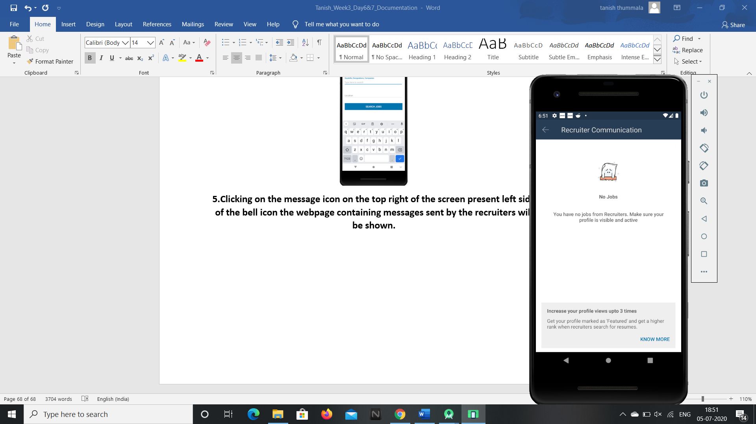

**6.Clicking on the bell icon on the top left corner of the screen the page containing the notifications will be shown.**

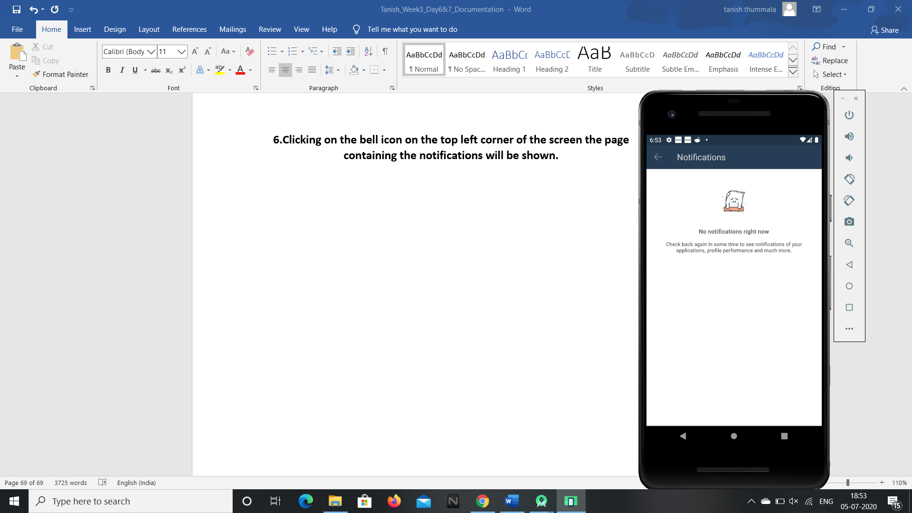

**So these are the features present in the Naukri android application and these features can be accessed by G1ANT Robot through Appium addon.**